Design & Implementation of Privacy-Preserving Technique
The safeguarding of the personal information has become a significant issue of cybersecurity in the contemporary data-driven environment. The use of sensitive data can cause identity theft, financial fraud and invasion of privacy. To solve this, I studied and applied a privacy-saving system based on two well-known methods, which are, K-Anonymity and Differential Privacy, on a structured personal dataset.
The data set was comprised of six records of personal characteristics, that is, Name, Age, ZIP code, and Salary. I used Python and Pandas and NumPy libraries in a Jupyter Notebook to implement the solution. This was implemented in three major phases.
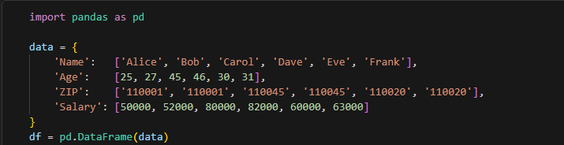
During the initial step, I used data suppression by eliminating the column of Name because this is a direct identifier, which can easily identify a person. In the second step, I carried out the data generalization on the Age attribute whereby the exact ages were grouped into a decade each (e.g., 25 → 20, 46 → 40). This made sure that there were at least two individuals with the same Age and ZIP combination, and the K-Anonymity condition could be met with k = 2. To programmatically ensure that this was true, I used a groupby check that returned True, affirming the guarantee of anonymity.
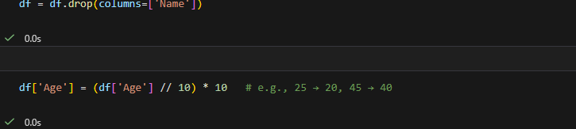
During the third step, I applied Differential Privacy by adding Laplace-distributed random noise in the Salary column with privacy budget of ε = 0.5. This made sure that one could not deduce the exact salary of any given person even with partial background information on the part of an attacker.
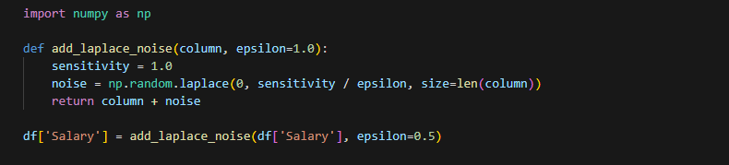
The last dataset still retained its analysis value and also prevented individual re-identification with great difficulty. This application helped me to see the practical significance of the data utility/data privacy balance in the context of the contemporary data protection and cybersecurity policy - one of the fundamental principles of the latter.
